23.42: a) 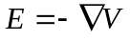
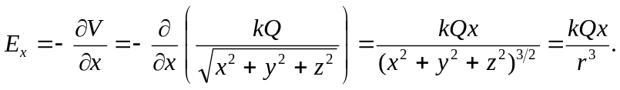

Similarly, 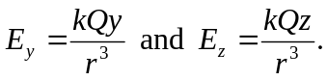
b) So from (a), 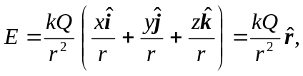 which agrees with Equation (21.7).

